E- Brgy Health Center Management System

An Undergraduate Thesis

Presented to the Faculty of

College of Information and Communications Technology

West Visayas State University

La Paz, Iloilo City

In Partial fulfilment

Of the Requirements for the Degree

Bachelor of Science in Information Systems and Information Technology

by

Maria Amcel T. Macabotas

Princess B. Pojol

Charlene Mae Pura

Colleen Tabago

June 2022

Approval Sheet

E- Brgy Health Center Management System

An Undergraduate Thesis for the Degree of

Bachelor of Science in Information Systems and

Information Technology

by

Maria Amcel T. Macabotas

Princess B. Pojol

Charlene Mae Pura

Colleen Tabago

Approved:

DR. JOEL T. DE CASTRO

Adviser

DR. REGIN A. CABACAS DR. MA. BETH S. CONCEPCION  
Chair, Information Systems Dean, CICT

June 2022

ii

Acknowledgment

This thesis would not have been possible without the guidance and the help of several individuals who, in one way to another, contributed their valuable assistance in the preparation and completion of this study.

To God Almighty for the guidance, the blessing that come in different forms and the strength and courage to survive the various challenges that hinder the path of success or the researchers.

The researchers’ families, Mr. and Mrs. Macabotas, Mr. Mrs. Pura, Mr. and Mrs. Pojol, Mr. and Mrs. Tabago, for their love, understanding, sacrifices, moral support, and financial support throughout the study;

All those people who supported in any respect during the completion of the thesis work;

Dr. Joel t. De Castro, Adviser, College of Information and Communication Technology, for the approval and for always lending his helping hand in the completion of this paper;

Dr. Regin Cabacas and Dr. Ma. Beth S. Concepcion  
for the Technical Assistance every defense and advises.

iii

The Researchers’ academic home, the College of Information and Communication Technology, and the rest of the supportive faculty and staff, for implanting in them the knowledge necessary for completion of this project.

These people have been seen the researchers’ endeavors throughout the end of the project to which they contributed great things deserving more than just words. To them the researchers gladly dedicated this project.

Macabotas, Maria Amcel T.  
Pojol, Princess B.

Pura, Charlene Mae C.  
Tabago, Colleen T.

June 2022

iv

“E- Brgy Health Center Management System.”

Macabotas, Maria Amcel T.; Pura, Charlene Mae C.;Pojol, Princess B.;Tabago,Colleen T. Unpublished Undergraduate Thesis, Bachelor of Science in Information Systems and Information Technology, West Visayas State University, Iloilo City, Philippines, October 2021.

Abstract

Barangay Health Center is community-based and the goal is to offer first aid, maternal and child health care, and other basic health services to all the constituents of the barangay. It is where the initial planning and implementation of projects and undertakings in the community takes place but ironically, it has the least amount of available information that serves as baseline for planning and policy implementation. This study focused on E- Brgy. Health Center Management System which design and develop systems that will track, report and give real-time update and monitoring of patients' incoming schedules. It will allow interactions and collaborations among patients and personnel of Brgy. Health Centers. It will also help track reports and give time monitoring of patients. The portal serves as a marketing arm of Brgy. Health Center. Based on the Jurors evaluation, the system developed by the researchers showed that it is well-functioning, feasible, adaptable, and very user friendly. The result showed that reliability, efficiency, usability, understandability, appropriateness of feedback to user, navigation, organization, correctness, and integrity of

v

the system were rank 5 which entailed positive feedback from the

respondents. The researchers concluded that the system accomplished the objectives of E-Brgy. Health Center Management System. It is then recommended to improve the system by adding complexity of queueing system, other relevant features and emphasizing of report generation.

vi

Table of Contents  
 Page

Title Page i  
Approval Sheet ii  
Acknowledgment iii  
Abstract v  
Table of Contents vii

List of Figures x

List of Tables xi

List of Appendices xii

Chapter

1.INTRODUCTION OF THE STUDY 13

Background of the Study 14  
 And Theoretical Framework

Objectives of the study 15  
 Significance of the study 16  
 Definition of terms 17  
 Delimitation of the study 23

2.REVIEW OF RELATED STUDIES   
 Review of Existing and Related Studies 24

vii

RESEARCH OF DESIGN AND METHODOLOGY   
 Description of the Study 30  
 Assumptions and Preconditions 31  
 Methods and Proposed Enhancement 32  
 Software Architecture 35  
 System Architecture 36  
 Database design 37  
 Procedural(flowchart)and object 39 oriented design  
 Process design (DFD) 42   
 System development Life Cycle 43

4.RESULTS AND DISCUSSION

Implementation 44

System Inputs and Outputs 46   
 Results Interpretation and Analysis 53   
 System Evaluation Results 54

5.SUMMARY, CONCLUSIONS, RECOMMENDATIONS   
 Summary of the study design and implementation 56  
 Summary of findings 57  
 Conclusions 58  
 Recommendations 59

References 60

viii

Appendices Page  
Appendix A – Letter to the Adviser 64  
Appendix B – Permission to Conduct Defense 65  
Appendix C – Letter for Data Gathering and Interview 66

Appendix D – Gannt Chart 68  
Appendix F – Sample Program Codes / Project Charter 69 Appendix G – Sample Questionnaires/Interview Forms 71

Appendix H – Software Quality Evaluation Form 72

ix

List of Figures

Figure Page

1. Software Architecture of the System 36
2. System Architectural Design 37
3. Database Design 38
4. Procedural Design (Health Worker) 40
5. Procedural Design (Doctor/Health Provider) 41
6. Procedural Design (Patient) 42
7. Process Design of the System 43
8. System Development Life Cycle 44
9. Log In Screen 47
10. Home Page of Secretary/Admin 47
11. Dash Board of Patients 48
12. SMS Notification 48

x

List of Tables

Table Page

1. Functional Correctness 57
2. Reliability 57
3. Usability 57
4. Gantt Chart 69
5. Sample Questionnaires/Interview Forms 72
6. Software Quality Evaluation Form 73

xi

List of Appendices

Appendix Page

1. Letter to the Adviser 64
2. Permission to Conduct Defense 65
3. Letter for Data Gathering and Interview 66
4. Gantt Chart 68
5. Sample Program Codes 69
6. Sample Questionnaires/Interview Forms 71
7. Software Quality Evaluation Form 72

xii

Chapter 1 INTRODUCTION TO STUDY

Background of the Study and Theoretical Framework

Nowadays the Brgy. Health workers have no centralized portal database documenting the data of patients, there are materials like paper used for forms and documents but the brgy. health workers have difficulty retrieving data from the past and it takes a lot of their time.

The Brgy. Health workers experience difficult in tracking datas, retrieving data of patients, and monitoring the schedule of check-up and appointment different patient’s data.

There is no strong web presence to update data and schedule of patients. Weak internet connectivity, no health management system provided, and budget allocated in the said barangay health center.

Thus, the researchers came up to design and develop a system for the Brgy. health center. For the health center, for them to easily track the schedule of appointment of patients, retrieve systematically the history of patients’ data, provide accurate, up-to-date, and complete information about patients, decrease actual waiting time by better time management and with the regulations to maintain a safe distance and a limit of maximum number of people.

This study supported by queuing theory which is determine the best way to set up and organize data. Queuing theory examines every component of waiting in line, including the arrival process, service process, number of servers, number of system places, and the number of patients/customers, data packets, or anything else.

Factors to consider in relation to the arrival of people at the health center include such things as the number of people, on average, who arrive within a given time frame, such as one hour.

Objectives of the Study

Generally, this study aimed to create a portal for E - Brgy. Health Center Management System.

Specifically, it aims to:

1. Design and develop systems that will track, report, and give real-time update and monitoring of patients' incoming schedules.

2. Generate Brgy. Health Center data for the different stakeholders.

3. Provide visualization analysis, interpretation of all patient’s data and understand the relationship pattern and trends.

Significance of the Study

The system aims to create a portal for E-Brgy. Health Center Management System which designs and develop systems that will track, report and give real-time update and monitoring of patients' incoming schedules.

It will not also make it easy to do business with the Brgy. Health Center, it will allow interactions and collaborations among patients and personnel of Brgy. Health Centers.

Easy data gathering, it will also help track reports and give time monitoring of patients. The portal serves as a marketing arm of Brgy. Health Center.

Definition of Terms

For better understanding, the following terms were defined conceptually and operationally:

Barangay Health Center - is a community-based and the goal is to offer first aid, maternal and child health care, communicable diseases, and other basic health services to all the constituents of the barangay.

In this study, Barangay Health Center is our main reason that we conducted this study. We developed an application that can be helpful for the patients and brgy health workers to make their consultation schedules more efficient.

Brgy. Health Workers- is a category of healthcare providers in the Philippines. They undergo a basic training program under an accredited government or non-government organization, and render primary care services in the community, research by Fe Espino at the [Research Institute for Tropical Medicine](https://en.m.wikipedia.org/wiki/Research_Institute_for_Tropical_Medicine).

In this study, the Brgy. Health Workers are in charge with the approval of registration request of the patients and they are the one taking responsibility in updating and inputting data such as schedules of consultations, announcements, reports in the system.

MongoDB- MongoDB is a source-available cross-platform document-oriented database program. Classified as a NoSQL database program, MongoDB uses JSON-like documents with optional schemas. MongoDB is developed by MongoDB Inc. and licensed under the Server-Side Public License (SSPL).

In this study, we used mongoDB as our database used for data management where it is a powerful way to store and retrieve data that allows developers to move fast.

Information -– facts provided or learned about something or someone. (Merriam-Webster).

  In this study, information is used to gather from every patient in the barangay health centers that serves as a data in our system, information is also generated by our system from the database as a data report for doctors consultation schedule.

API (Application Programming Interface) -– which is a software intermediary that allows two applications to talk to each other. Each time you use an app like Facebook, send an instant message, or check the weather on your phone, you're using an API.

  In this study, API (Application Programming Interface) is used to neutralize and communicate the database, patients, Brgy Health secretary, and the doctor. It can easily retrieve data from the database.

    JSON Web Token - is an Internet proposed standard for creating data with optional signature and/or optional encryption whose payload holds JSON that asserts some number of claims. The tokens are signed either using a private secret or a public/private key.

In this study, JSON Web Token is to determine the ID number of the patients from the database. Patients, Brgy. Health Workers and Doctors could then use that token to prove that it is logged in as a registered person.

SMS (Short Message Service) - Invented in the 1980s and defined in the 1985 GSM standards, it is one of the oldest texting technologies. It is also the most widespread and frequently used. MMS stands for Multimedia Messaging Service.

In this study, SMS is only used if the patients are using keypad phones, they will receive a text message from Brgy. Health Center for any updates and about their schedules prior to their concerns.

     React JS (Javascript) -- React is an open-source, front end, JavaScript library for building user interfaces or UI components. It is maintained by Facebook and a community of individual developers and companies. React can be used as a base in the development of single-page or mobile applications.

Node JS / EXPRESS -- Express is a minimal and flexible Node.js web application framework that provides a robust set of features to develop web and mobile applications. It facilitates the rapid development of Node based Web applications. Following are some of the core features of Express framework −

Allows to set up middle wares to respond to HTTP Requests.

Defines a routing table which is used to perform different actions based on HTTP Method and URL.

Allows to dynamically render HTML Pages based on passing arguments to templates.

React Native- is an open-source mobile application framework created by Facebook, Inc. It is used to develop applications for Android, Android TV, iOS, macOS, tvOS, Web, Windows and UWP by enabling developers to use Reacts framework along with native platform capabilities.

Representational state transfer (REST)- is a software architectural style which uses a subset of HTTP.[1] It is commonly used to create interactive applications that use Web services. A Web service that follows these guidelines is called RESTful.

Schema- in computer programming is the organization or structure for a database. It can also be used in regard to math’s where a schema is a formal expression of an inference rule for artificial intelligence computing. A schema is created through modelling and is used when talking about both relational databases and object-oriented databases.

Route- is a section of Express code that associates an HTTP verb ( GET , POST , PUT , DELETE , etc.), a URL path/pattern, and a function that is called to handle that pattern. There are several ways to create routes.

     Database connection- is a facility in computer science that allows client software to talk to database server software, whether on the same machine or not. A connection is required to send commands and receive answers, usually in the form of a result set.

Middleware- is software that lies between an operating system and the applications running on it. Essentially functioning as hidden translation layer, middleware enables communication and data management for distributed applications.

Digital Asset- is any digital material owned by an enterprise or individual including text, graphics, audio, video and animations.

Redux- is a predictable state container designed to help you write JavaScript apps that behave consistently across client, server, and native environments and are easy to test.

Design System- is a series of components that can be reused in different combinations. Design systems allow you to manage design at scale.

Data Type- simply type is an attribute of [data](https://en.wikipedia.org/wiki/Data) which tells the [compiler](https://en.wikipedia.org/wiki/Compiler) or [interpreter](https://en.wikipedia.org/wiki/Interpreter_(computing)) how the programmer intends to use the data. Most programming languages support basic data types of [integer](https://en.wikipedia.org/wiki/Integer_(computer_science)) numbers (of varying sizes), [floating-point](https://en.wikipedia.org/wiki/Floating_point) numbers (which approximate real numbers), [characters](https://en.wikipedia.org/wiki/Character_(computing)) and [Booleans](https://en.wikipedia.org/wiki/Boolean_data_type).

Utility Function- represents the satisfaction or pleasure that consumers receive for consuming a good or service. It measures consumers' preferences for a set of goods and services. Utility is measured in units called utils—the Spanish word for useful— but calculating the benefit or satisfaction that consumers receive is abstract and difficult to pinpoint.

Dependencies- are specified in a simple object that maps a package name to a version range. The version range is a string which has one or more space-separated descriptors. Dependencies can also be identified with a tarball or git URL.

Delimitation of the Study

The E-Brgy. Health Center Management System is a web application. Each data given by the respondents, was encoded by the researchers to the system. The system is accessible using mobile phones and through the web.

The users may download the app and set an appointment online or may log in through the website. The system delimits that the system may not be accessible to those people who don't have an android phone or don't know how to use a computer. It also delimits those who don't have an internet connection however they can connect through the WiFi provided by the Brgy. health center.

Chapter 2 REVIEW OF RELATED STUDIES

Review of Existing and Related Studies

The use of the following related systems are discussed below;

*A blockchain based patient centric electronic health record storage and integrity management for e-Health systems*

*According to* Usharanichelladuraib retrieved 2021, this study are related in the digitization of health records, patients and doctors find difficulty in accessing their health records, especially when the health records are fragmented with different health service providers. In this study, Patient Centric block chain smart contracts are designed to provide a regulated solution to the requirements of patients, doctors, and health service providers with integrity management.

This related system launches smart contracts namely registration contract for immutable patient log creation. Health Record Creation Contact to generate digital health records. Health record storage contract for secure storage and rapid access with a new modified Merkle tree data structure. Update permission Contract that can provide access at emergency situations. Data sharing permission contract for exchange of health records between different stakeholders and viewership permission contract for viewing the health information by the patients for home care and future care.

This related study has been carried out on a number of trials to check the effectiveness. The qualitative and quantitative metrics of this related system have been measured to evaluate the performance of resources, transactions per second, and the latency of transactions.

This related system provides high security and integrity through cryptographic hash functions. The results are encouraging.

*Evaluation and Design of Public Health Information Management System for Primary Health Care Units Based on Medical and Health Information.*

Which is based on electronic health records, virtual private network technology, real-time data storage, and other technologies, is designed on the premise of economical and straightforward operation. The Xinhua Community Health Service Center around the Wulong Street, Longsha District, Qiqihar City is selected as the experimental unit of the public health information management system, and the work efficiency of the system in the public health perspective of the primary medical unit is evaluated after 12 months of system operation.

The public health information management system of primary medical units has the following comprehensive management functions: health record management, child health, maternal health, health of the elderly, health of patients with chronic diseases, health of severe psychiatric patients, health education, infectious diseases and public emergencies, health events, health supervision, and management information. In addition, after 12 months of the information management system operating in the grassroots units, the results show that patients and doctors have a very high satisfaction rate with the system. This related system is not only cultivating the excellent health and disease prevention awareness of residents but also improves the efficiency of primary care institutions, as well as reducing the number of patients seeking medical care.

This study design as rich in functions with prominent work efficiency, which significantly improves the public health of grass-roots medical units.

*E-Health Management System*

The E-Health Management system provide comprehensive, effective, and efficient solution for carrying out management of hospitals and clinics fulfilling the needs and requirements of all stakeholders such as doctors, patients, and staff. This system provides the benefits of streamlined operations, enhanced administration & control, superior patient care, strict cost control and improved profitability. Hospital Management Systems are in high demand to handle increasing population needs and also aids the practicing doctors and hospital service and support staff with timely service and precision. There are varied metrics available to assess the performance of services like hospital industry, and the successful implementation and usage of Hospital information systems forms a crucial role. After extensive research had been carried out on the hospital management process, they proposed a cloud-based web application for the system which will provide a comprehensive, effective and efficient solution for carrying out management of hospitals fulfilling the needs and requirements of all stakeholders such as doctors, patients and staff. An authorized doctors and assisting staff to access the medical history of patient efficiently, appointment and reminder system for patients. To build a built-in medical solutions repository based on historical and statistical data. To let the doctors and surgeons build their profile and personal repository in which they may store their routine medicines names, precautions instructions and can take required help from this repository later when needed.

*A queuing system for inert construction waste management on a reverse logistics network*

According to Xueqing Zhang and Rana Rabnawaz Ahmed many cities worldwide have built various types of facilities to manage the large amounts of construction waste generated year by year. This research develops a queuing system to improve the management of inert construction waste (ICW). This related study combines the queuing theory, a reverse logistics network (RLN) and a simulation function. The RLN integrates the sources of waste generation, the collecting and recycling facilities and the landfills, and the simulation function simulates the different processing capacities of the queuing system and the weekday and weekend operations of the facilities in the RLN. A comprehensive case study based on the practice of [ICW management](https://www.sciencedirect.com/topics/engineering/construction-waste-management) in Hong Kong further substantiates the utility of the queuing system.

*Data Management and Integration with Electronic Health Record Systems*

This system been the automatic data acquisition, transfer,

and integration among various systems ranging from the collect of patient data to the final repository.

In this study, the author outlines the current state of data management, transfer, and integration and highlights remaining problems that exist as they pertain to the cardiac implantable electronic device (CIED). The ideal state would be that information is created by the CIED and then transferred to multiple systems with no manual data entry or data manipulation to positively affect patient care while minimizing data error. Unfortunately, this is not yet the situation.

The CIED remote monitoring can retrieve information from a patient’s device without requiring the patient to come to the clinic and electronically forward it to the responsible physician. Such systems now can interrogate the patient’s device automatically without any interaction with the patient. This information is then sent to a unique central receiving system for each patient for processing and transmission to the responsible physician.

*Internet of things sensor assisted security and quality analysis for health care data sets using artificial intelligent based heuristic health management system*

On this study the effective management of health records leads to an increase in the importance of the healthcare management system all over the world. A real-time health monitoring system is a key zone for the Internet of Things (IoT) sensor technology in human services using Big Data Analytics. In this study, an artificial intelligence-based heuristic health management system has been designed and developed. This related study is exceptionally close to improve the security and privacy of the live datasets of patients and the association of medicinal services over its different viewpoints. These services include the capacity for specialists, experts, attendants, and staff to settle on better decisions faster.

Chapter 3 RESEARCH DESIGN AND METHODOLOGY

Description of the Study

The study aimed to visualize the data of a certain area which has a brgy. health centers and to also visualize the method used for consultation’s appointment. The study also defines and provides visualization analysis of all patients and data and understands the relationship pattern and trends. It will give real-time updates and monitoring of patients’ incoming schedules and will track and generate reports.

  The web application can be used by the assigned health workers, doctors and also patients with only limited access to the app. The health worker can approve the patients request for the scheduled consultation appointment and can manage the queuing while the Doctor can view the list of his/her patients and can also put remarks on the patient’s data sheet and can easily view patient’s consultation history if it is a follow up check-up or a new one. The patients can view available slots in each consultation category, schedule the desired time and date, the patients can also cancel the said appointment, the queuing number will appear on the patients dashboard right after he/ she is approved by the health worker. This system can also give the data reports needed during the end of the month.

Assumptions and Preconditions

The following Assumption and preconditions are required for E-brgy health center management system to start operation successfully:

The research study is anchored on the assumption that the health center's staff have provided valid and reliable information upon interview by the researcher. In addition, the research study is believed to be timely relevant due to the current pandemic that will result into an outcome providing a queueing system that will be useful for health center's staff.

Pre-condition

The required system components are installed on the participating machines (usable for phone, laptop), and the queue administrator (secretary/admin), if any, is initialized on each machine.

Storage devices are configured and available and have enough space to store the system state and data access.

The required transport protocols are available and fully initialized on the participating machines security and confidentiality packages are available to the system.

Methods and Proposed Enhancements

Health care workers were consulted in the design, implementation, and evaluation stages of each iteration of the system. Thus, the resulting system is one that they would be happy to use. The system achieves the goals of being able to create and manage patient records, the system will track report and give real-time update and monitoring of patient’s incoming schedules, it generates report and provide visualization analysis, interpretation of patient’s data.

The methodology we used was software development life cycle (SDLC), which we felt was the most effective methodology to use when developing our system. The system development has gone through different phases such as planning, data gathering, analyzing, software design, programming stage and implementation. Every stage is properly documented for validity of the process.

  The first phase is planning. In this stage, researchers came up with the idea which was suggested by the adviser to provide a system for the barangay health center that would help them in visualizing the information using the web application with the aid of the Open data and the public information.

  In the data gathering phase, the researchers focused on the requirement of development and implementation by conducting an informational interview at the Barangay Health Center – Tubungan, Iloilo, Molo, Iloilo City, Pavia, Iloilo and on the health centers regarding their current system.

  In the analysis phase, the data were reviewed and analyzed. The strengths and weaknesses of the study were also the basis for the development of the decisions. Also, in this stage the researchers searched for related systems about the topic, evaluated the gathered information and ensured that the system would be possible.

  In the designing phase, the researchers designed a public-friendly phase for the users to easily operate and understand the system. They also used an ERD, DFD, and Flowchart to show the system’s process.

  In the programming stage, the researchers focused on the functionality and efficiency of the system. Visual studio was used in encoding the data gathered by the researchers.

  Testing and debugging were also done to check the efficiency of the system and to check the errors to be corrected.

The Architectural Designs show the structural components of the system.

The Health Worker assigned, and the user must connect to the internet, the Health Worker manages the medical consultations categories, also accepts appointment requests submitted by patients, manages queuing slots in each medical consultation category, manages time schedule and register Doctor. On the user side, he/she will register to the site, fill up forms on desired medical category consultation and set the time and date for appointment

Components and Design

*Software Architecture*

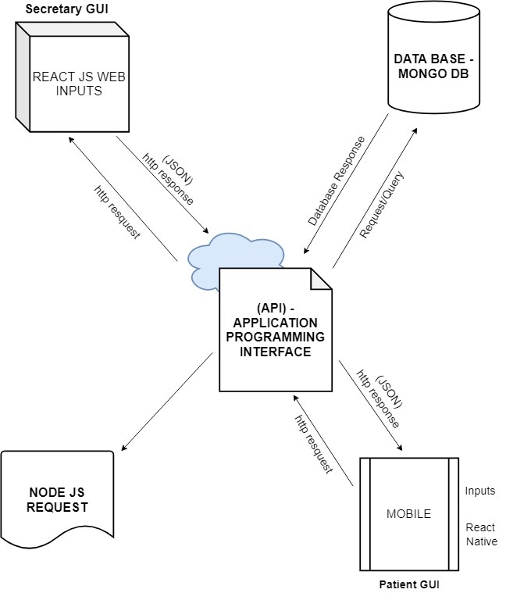

**Figure 1.** Software Architecture of the System

These functions used to gather from every patient that serves as a data in our system, information is also generated by our system from the database as a data report.

**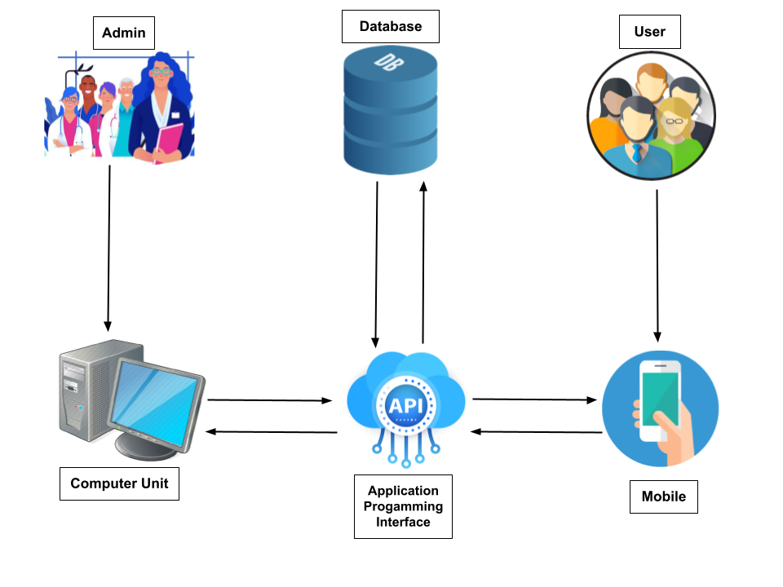***System Architectural Design*

**Figure 2.** Software Architecture of the System

Shows the procedure of the website and server on how it works. The system is accessible using mobile phones and through the web. The users may download the app and set an appointment online or may log in through the website.

*Database Design*

**Figure 3.** Database Design

It organized collection of data stored and accessed electronically.

Procedural Design

The procedural design explains the procedural details using any of the graphical or tabular design notations such as structured flowchart. Illustration of the procedural details on how to operate the system and its process is illustrated in the chart that follows.

**Figure 4.** Procedural Design (Health Worker)

Shows the process flow followed by the Health Worker may in charge with the approval of registration request of the patients and they are the one taking responsibility in updating and inputting data such as schedules of consultations, announcements, reports in the system.

**Figure 5.** Procedural Design (Doctor/Health Provider)

on the patients data sheet and can easily view patients consultation history if it is a follow up check-up or a new one.

**Figure 6.** Procedural Design (Patient)

Shows the process flow followed by the Patient, it views available slots in each consultation category, schedule the desired time and date, the patients can also cancel the said appointment, the queuing number will appear on the patients dash board right after he/ she is approved by the Health Worker.

**Figure 7**. Process Design of the System

**Figure 8.** System Development Life Cycle

The system development has gone through different phases such as planning, data gathering, analyzing, software design, programming stage and implementation. Every stage is properly documented for validity of the process.

CHAPTER 4 RESULTS AND DISCUSSION

Implementation

In order to begin the whole process all the necessary software needed to be installed onto our testing server. Java script was the main programming language for web and database application, HTML for the design of the system. The System was done in order to test its functionalities and determine factors that can affect how the system run and also to determine possible problems that the system may encounter.

The website development was divided into three sections, namely the user registration/login section, the Doctor system section, and the admin section.

The administrator or health worker assistant is responsible for the system’s maintenance and for providing a user manual for the functionalities of the system.

The system is a web application and was tested several times to ensure its functionality. Factors that can affect the system were also determined. The software has been tested for compatibility with the system. Debugging has been conducted to ensure its capability to make the system function properly according to the desired output.

The researchers identified two towns, Pavia and Tubungan rural health centers to test and run the E-Brgy. Health Center Management System.

Letters has been sent to the two rural health centers to implement the said system.

The Pavia and Tubungan Rural Health Centers tested the system several times to insure its functionality. Also, the rural health centers personnel checked the system software for its compatibility if it’s easily operated. According to the desired output the Pavia and Tubungan Health Centers conducted a debugging to ensure its compatibility to make the system functioned properly according to its used, efficiency, and effectivity.

The Pavia and Tubungan Health Centers had tested the Researchers E.Brgy Health Center Management System and concluded that it is well-functioning, feasible, adaptable and very user friendly.

System Inputs and Outputs

**Figure 9.** Log In Screen

**Figure 10.** Home Page of Secretary/Admin

**Figure 11.** Dash Board of Patients

**Figure 12.** SMS Notification

The system allows admin to set schedules or appointments, datas of the patients and print out reports. The actual (figure9), in this dashboard, the admin can add, edit, delete information, and cancel appointments schedules that stored in database. The user can login or register in the Homepage (Figure11). The user can select appointments and set schedule for checkup and can also view upcoming consultations schedules (Figure11). The user can also view their scheduled appointments and can logout in their account. The system can send SMS notification if when the patient is close to his slot or queued number (Figure12).

Technical Specifications

Certain requirements and specification are necessary for the system to be employed and offered. These specific prerequisites must be complied in order to avoid unwanted effects to happen and to ensure the efficiency of the system and that it will be beneficial to users’ operation.

Software Specifications

The system entailed some software requirements in order to employ the functionalities and effectiveness of the system.

Java Script was the main programming language for web and database application, HTML for the design of the system.

User Specification

Basic skills and knowledge in using computer and phones are the basic requirements of the system user since the system was developed to be user-friendly.

Hardware Specification

For the local control system, a Windows 7 Operating System is preferred to be used in the system because it can handle assembly language commands for the navigation, any brand or type of keyboard and mouse will do.

For the devices, any devices as long as it can access the internet.

Results Interpretation and Analysis

This chapter presents the findings, analysis and interpretation of data gathered whose main objective is to find out the expectations and perceptions of the patient’s towards Brgy. Health Centers.

The researchers conducted a survey regarding the system and it gives positive response from the staff that the system is a big help to the Barangay Health Center. It is easy to navigate, add appointments and schedule. They can easily track data and review patients’ information. They can now generate visualization report.

More specifically, the researchers sought to meet the following objectives of the system.

System Evaluation Results

The response to the system was generally very positive, the users as a whole felt very satisfied after using the system, they found the system very easy to use and navigate across. They generally felt that the record management system would improve efficiency greatly.

A frequency distribution is a representation that displays the number of observations within a given interval. Below is the Frequency distribution result of this study based on the User Acceptance Evaluation.

The criteria evaluation involves the following:

Reliability, efficiency, usability, understandability, appropriateness of feedback to user, navigation, organization, correctness, and integrity.

The evaluation form also included spaces for jurors’ recommendation for the improvement of the system.

In this activity evaluation was distributed to two brgy health center to measure if the defined were achieved goals in accordance with the system effectiveness, efficiency, and user’s satisfaction.

*Result of the Evaluation conducted on the respondents*

**Table 1.** Functional Correctness

**Table2.** Reliability

**Table3.** Usability

CHAPTER 5 SUMMARY, CONCLUSIONS, AND RECOMMENDATIONS

Summary of the Study design and implementation

The system is composed of mobile applications to help the user systematize their data’s and develop systems that can track, report, and give real-time update and monitoring of patients' incoming schedules. Generate Brgy. Health Center data for the different stakeholders. Provide visualization analysis, interpretation of all patient’s data and understand the relationship pattern and trends.

Currently, brgy health centers deploy a paper-based record management system, relying heavily on files that are easily lost and are inefficient to use, ultimately to the detriment of the patient. Brgy. health centers are becoming far more overcrowded and the possibility of human errors when processing these paper-based files is very real.

Through our interactions with real healthcare workers, we have devised a web interface that allows creation of patient records, can track, report, and give real-time update and monitoring of patients' incoming schedules.

The response to the system was generally very positive, the users as a whole felt very satisfied after using the system, they generally felt that the record management system would improve efficiency greatly.

Summary of the Findings

The main discovery we noticed when developing the system occurred during the initial user requirements section of the project where our focus was displaying different data values from variety of sensors, was found to be not as valuable as expected, whereas we found out that there is a great need for a web-based record system, thus this finding greatly give guidance in our work. That being the main emphasis of the project shifting from visualizing sensor data to creating a E-Brgy Health Center Management System, which was thought of being incredibly useful in brgy. health centers.

The effectiveness of the Open-Source aspect of our project was also an interesting finding. We achieved desirable results with our open source servers and database systems without having to purchase commercial packages in quality, reliability and capability. During project we developed a lost of requirements for an effective web-based system for patient records and give real-time update and monitoring of patients' incoming schedules.

Conclusions

The researchers there concluded that the system had successfully accomplished the set objectives of E - Brgy. Health Center Management System:

The Design and develop systems that will track, report and give real-time update and monitoring of patients' incoming schedules.

Generate Brgy. Health Center data for the different stakeholders.

Provide visualization analysis, interpretation of all patient’s data and understand the relationship pattern and trends.

Recommendations

1. Add complexity of queuing system, add more data on how queuing use.
2. Revise objectives to reflect complexity of the queuing system, might be to add a prediction of the allotted time for consultation and/or transactions.
3. Add more relevant features, report generation must be emphasized.

References

Author: Ellen-Marie Whelan

*The Importance of Community Health Centers*. (2010, August 9). Americanprogress.Org. Retrieved March 19, 2022, from <Https://Www.Americanprogress.Org/Article/The-Importance-Of-Community-Health-Centers/>

Eunice Mallari, Gideon Lasco, Don Jervis Sayman, Arianna Maever L. Amit, Dina Balabanova, Martin McKee, Jhaki Mendoza, Lia Palileo-Villanueva, Alicia Renedo, Maureen Seguin & Benjamin Palafox. (2020). Connecting communities to primary care: a qualitative study on the roles, motivations and lived experiences of community health workers in the Philippines. *Connecting Communities to Primary Care: A Qualitative Study on the Roles, Motivations and Lived Experiences of Community Health Workers in the Philippines*. <https://bmchealthservres.biomedcentral.com/articles/10.1186/s12913-020-05699-0>

Gerald A.SerwerMD. (2021). Data Management and Integration with Electronic Health Record Systems. *Data Management and Integration with Electronic Health Record Systems*.

U.S.H.A.R.A.N.I.C.H.E.L.L.A.D.U.R.A.I.B. (2021). *A blockchain based patient centric electronic health record storage and integrity management for e-Health systems*. USHARANICHELLADURAIB. Retrieved 2021, from https://www.sciencedirect.com/science/article/abs/pii/S2211883721000368

Bridget Botelho, Jack Vaughan,. (2020). MongoDB. *MongoDB*. https://www.techtarget.com/searchdatamanagement/definition/MongoDB

Andrew D Madden. (2020). Enterprise Information System, Information Value and Economic Security of Enterprise. *Enterprise Information System, Information Value and Economic Security of Enterprise*. http://dx.doi.org/10.7441/dokbat.2020.37

Camille Siegel, Arun Dorairajan. (2020). What is an API? *What Is an API?* https://blog.axway.com/amplify-products/api-management/what-is-an-api

Mowafa Househ. (2014). The role of short messaging service in supporting the delivery of healthcare: An umbrella systematic review. *The Role of Short Messaging Service in Supporting the Delivery of Healthcare: An Umbrella Systematic Review*. https://doi.org/10.1177%2F1460458214540908

Louise Frindlay. (2020). Introduction to Express.js. *Introduction to Express.Js*. https://www.section.io/engineering-education/express/

Sarah Lewis,. (2019). React Native. *React Native*. https://www.techtarget.com/searchapparchitecture/definition/React-Native

Roy Thomas Fielding. (2000). Architectural Styles and the Design of Network-based Software Architectures. *Architectural Styles and the Design of Network-Based Software Architectures*. <https://www.ics.uci.edu/~fielding/pubs/dissertation/top.htm>

Andrew Zola. (2021). schema. *Schema*. <https://searchsqlserver.techtarget.com/definition/schema>

Ivy Wigmore. (2012). controller. *Controller*. <https://www.techtarget.com/whatis/definition/controller>

Mark T. Thomas. (2022). Routing with React in Modern Front-End Web Applications. *Routing with React in Modern Front-End Web Applications*. <https://freecontent.manning.com/routing-with-react-in-modern-front-end-web-applications/>

Shivam Kapoor. (2020). What Is Middleware? *What Is Middleware?* <https://www.pillir.io/edgeucation-center/blog/what-is-middleware>

Ralph Windsor. (2016). Re-Defining The Meaning And Scope Of Digital Assets – Part 1. *Re-Defining The Meaning And Scope Of Digital Assets – Part 1*. <https://digitalassetmanagementnews.org/features/re-defining-the-meaning-and-scope-of-digital-assets-part-1/>

Dan Abramov And Andrew Clark. (2021). Redux (JavaScript library). *Redux (JavaScript Library)*. <https://dbpedia.org/page/Redux_(JavaScript_library)>

Therese Fessenden. (2021). Design System 101. *Design System 101*. <https://www.nngroup.com/articles/design-systems-101/>

Kenneth Leroy Busbee And Dave Braunschweig. (2021). Programming Fundamentals. *Programming Fundamentals*. <https://press.rebus.community/programmingfundamentals/>

Appendix A

Letter to the Adviser

West Visayas State University

College of Information and Communications Technology

La Paz, IloIlo City

October 10, 2020

DR. JOEL DE CASTRO  
Faculty, College of Information Communication Technology  
West Visayas State University   
Luna Street, Lapaz, Iloilo city

Dear Sir;

Greetings!

We, the undergraduate students of West Visayas State University pursuing a degree in Bachelor of Science in Information Systems/Information Technology, are currently enrolled in Thesis Writing.

We are writing to humbly request your service and expertise to serve as an adviser for our thesis.

We believe that your knowledge and insights will be valuable and will greatly enrich our work.

Thank you for your consideration and we hope you will be able to fulfill our request.

Respectfully yours,

Maria Amcel T. Macabotas

Princess Pojol

Charlene Mae Pura   
Colleen T. Tabago

Approved/Disapproved

Dr. Joel De Castro  
Faculty, CICT  
West Visayas State University

Appendix B

PERMISSION TO CONDUCT DEFENSE

West Visayas State University

College of Information and Communications Technology

La Paz, IloIlo City

January 20, 2021

DR. MA. BETH S. CONCEPCION  
Dean, College of Information Communication Technology  
West Visayas State University   
Luna Street, Lapaz, Iloilo city

Dear Madam;

Greetings!

We, the undergraduate students of West Visayas State University pursuing a degree in Bachelor of Science in Information Systems and Bachelor of Science in Information Technology, are currently enrolled in Thesis Writing.

We are writing to humbly request to conduct the thesis defense in your convenient time.

Your appropriate approval will help us in completion of this study.

Thank you for your consideration.

Respectfully yours,

Maria Amcel T. Macabotas

Princess Pojol

Charlene Mae Pura   
Colleen T. Tabago

Noted by: Approved/Disapproved

Dr. Joel De Castro DR.MA.BETH S. CONCEPCION  
Thesis adviser Dean, College of ICT  
 WVSU

Appendix C  
Letter for Data Gathering and Interview

Letter for Data Gathering and Interview in Pavia, Iloilo

West Visayas State University

College of Information and Communications Technology

La Paz, IloIlo City

April 15, 2021

HON. ANTHONY G. GORRICETA  
Municipal Mayor  
Pavia Iloilo

Dear Mayor Gorriceta:

Greetings!

We are the students from West Visayas State University pursuing a degree in Bachelor of Science in Information Systems/Information Technology. It is requirements of the university that all students must carry out research projects in partial fulfilment of the degree’s requirements. Our thesis entitled “E-brgy, Health Center Management System”.

In connection with this, we would like to ask to conduct interview in your good office. Rest assured that the data we will gather will remain confidential and to be used on academic purposes only.  
We believe that you are with us in our enthusiasm to finish this requirement as compliance for our graduation and to develop our well-being. We hope for your positive response on this matter.

Your approval to conduct this study will be greatly appreciated. For further question please contact us at 09517375534.  
Thank you very much!

Respectfully yours,

Maria Amcel T. Macabotas

Princess Pojol

Charlene Mae Pura   
Colleen T. Tabago

Noted by:

Dr. Joel De Castro  
Thesis Adviser, CICT  
West Visayas State University

Letter for Data Gathering and Interview in in Tubungan, Iloilo

April 19, 2021

HON. ROQUITO G. TACSAGON   
Municipal Mayor  
Tubungan Iloilo

Dear Mayor Tacsagon:

Greetings!

We are the students from West Visayas State University pursuing a degree in Bachelor of Science in Information Systems/Information Technology. It is requirements of the university that all students must carry out research projects in partial fulfilment of the degree’s requirements. Our thesis entitled “E-brgy, Health Center Management System”.

In connection with this, we would like to ask to conduct interview in your good office. Rest assured that the data we will gather will remain confidential and to be used on academic purposes only.  
  
We believe that you are with us in our enthusiasm to finish this requirement as compliance for our graduation and to develop our well-being. We hope for your positive response on this matter.

Your approval to conduct this study will be greatly appreciated. For further question please contact us at 09517375534.  
  
Thank you very much!

Respectfully yours,

Maria Amcel T. Macabotas

Princess Pojol

Charlene Mae Pura  
Colleen T. Tabago

Noted by:

Dr. Joel De Castro  
Thesis Adviser, CICT  
West Visayas State University

Appendix D

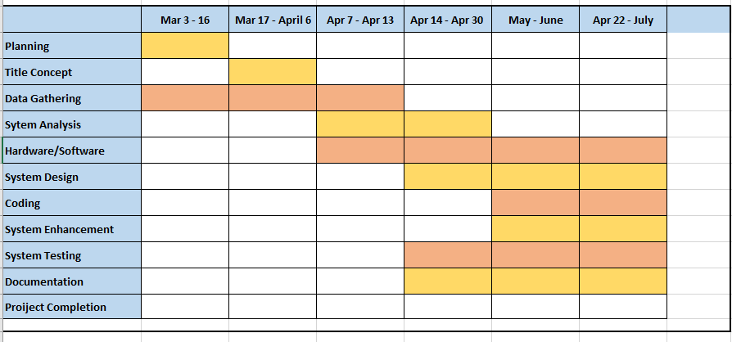Table 4. Gantt Chart

Appendix F – Sample Program Codes

Doctors.controllers.js

const ErrorResponse = require("../utils/ErrorResponse");

const asyncHandler = require("../middlewares/asyncHandler");

const Doctors = require("../models/Doctors");

exports.createDoctor = asyncHandler(async (req, res, next) => {

    const doc = await Doctors.create(req.body);

    res.status(201).json({ success: true, data: doc });

});

exports.retrieveDoctors = asyncHandler(async (req, res, next) => {

    res.status(200).json(res.advancedResults);

});

exports.retrieveOneDoctor = asyncHandler(async (req, res, next) => {

    const doc = await Doctors.findById(req.params.id);

    if (!doc) {

        return next(

            new ErrorResponse(

                `Doctor not found with ID of ${req.params.id}`,

                404

            )

        );

    }

    res.status(200).json({ success: true, data: doc });

});

exports.updateOneDoctor = asyncHandler(async (req, res, next) => {

    let doc = await Doctors.findById(req.params.id);

    if (!doc) {

        return next(

            new ErrorResponse(

                `Doctor not found with ID of ${req.params.id}`,

                404

            )

        );

    }

    const updateDoc = await Doctors.findByIdAndUpdate(

        req.params.id,

        req.body,

        {

            runValidators: true,

            new: true,

        }

    );

    res.status(200).json({ success: true, data: updateDoc });

});

Appendix G

Table 5. Sample Questionnaires/Interview Form

Table 6. Software Quality Evaluation Form

Disclaimer

This software project and its corresponding documentation entitled “E-BRGY, HEALTH CENTER MANAGEMENT SYSTEM” is submitted to the College of Information and Communications Technology, West Visayas State University, in partial fulfillment of the requirements for the degree, Bachelor of Science in Information Systems and Information Technology.

It is the product of our own work, except where indicated text.

We hereby grant the College of Information and Communications Technology permission to freely use, publish in local or international journal/conferences, reproduce, or distribute publicly the paper and electronic copies of this software project and its corresponding documentation in whole or in part, provided that we are acknowledged.

[Author Maria Amcel T. Macabotas]  
[Author Princess B. Pojol ]

[Author Charlene Mae C. Pura]

[Author Colleen T. Tabago]

[June 2022]